**MILESTONE 1- STOCK MARKETING**

**NAME:** T.MANIPRIYA

**EMPLOYEE ID:** 761131

**MAIL:** [Manipriya.T@cognizant.com](mailto:Manipriya.T@cognizant.com)

**LOCATION:** Siruseri, Chennai

**1.SCHEMA DIAGRAM**

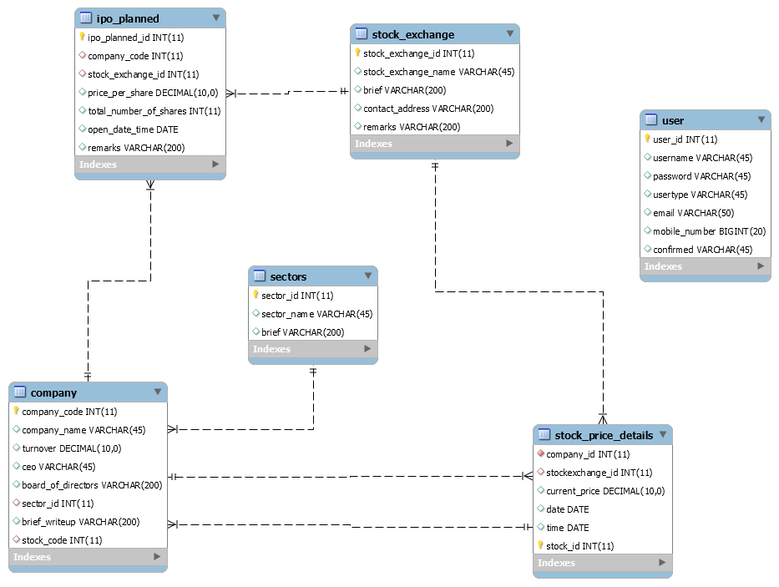

**2.HTML SCREENS**

* 1. **LOGIN PAGE**

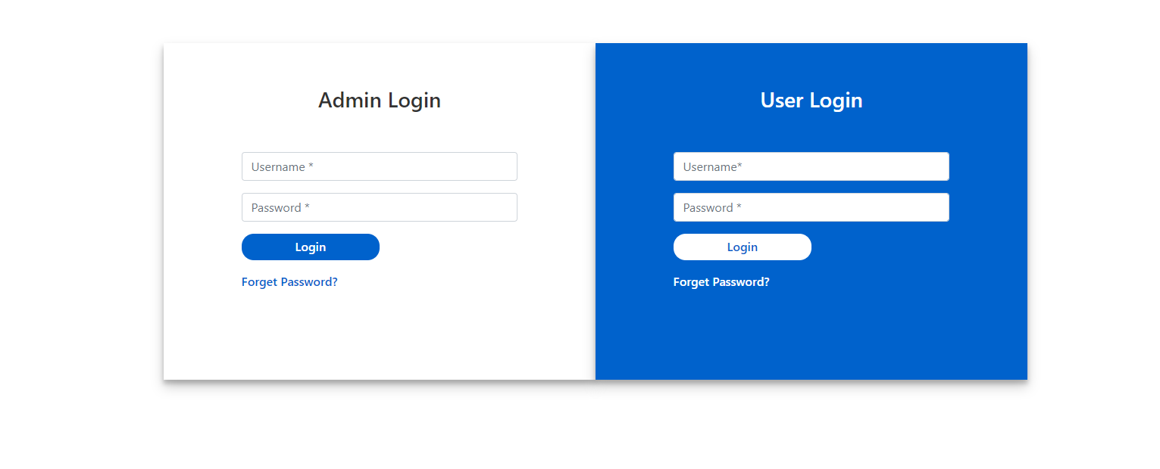

* 1. **ADMIN LANDING PAGE**



* 1. **IMPORT DATA**

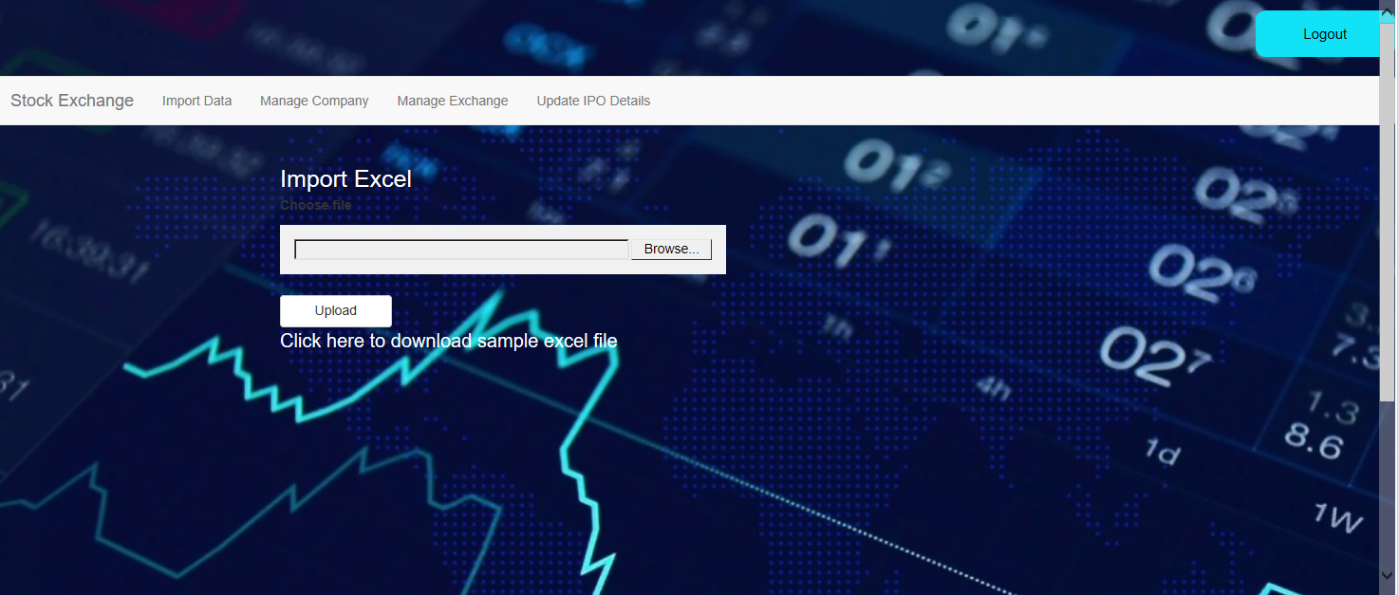



* 1. **CREATE COMPANIES**



* 1. **MANAGE COMPANIES**

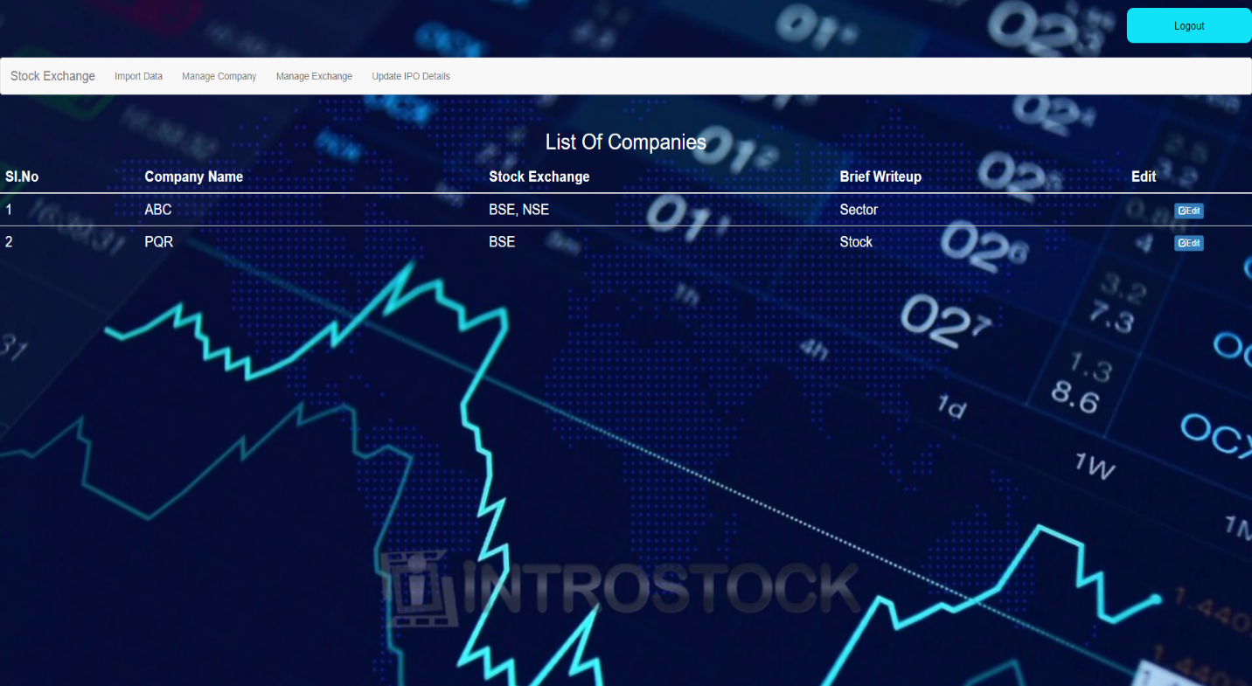

* 1. **USER LANDING PAGE**



* 1. **COMPARE COMPANIES**



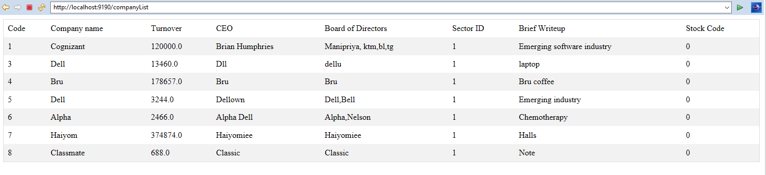

**GITHUB LINK:**

<https://github.com/ManipriyaThirumurugan/SpringBoot_StockExchange_Manipriya>